Irregular Curved Shapes
# Source: AI Source: Provided by: [Data Path: Persons Table -> ID Column: 1, Name_En Column: Motasem Essam] -> From: [ChatGPT] on [7/25/2026]
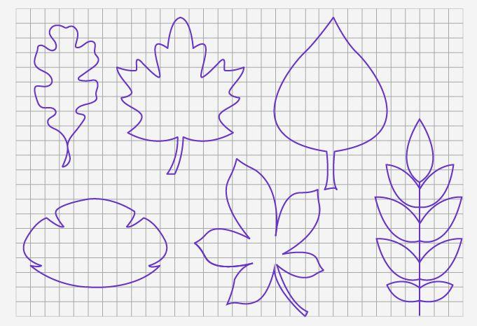
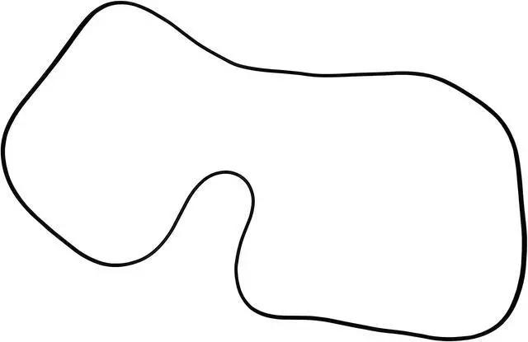
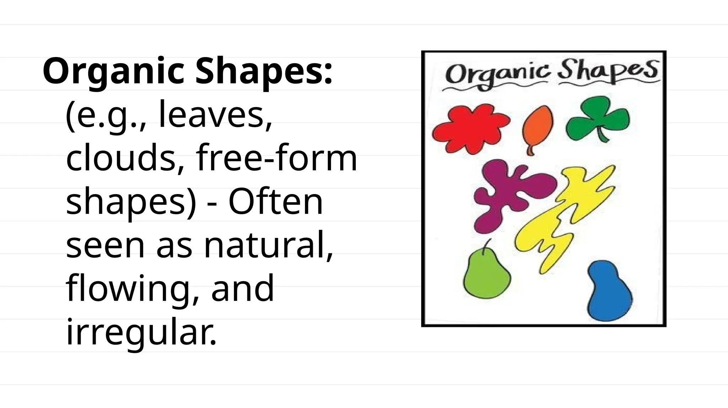
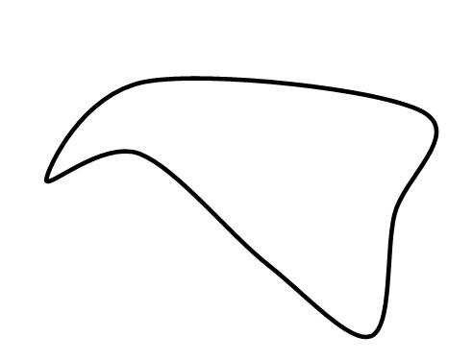
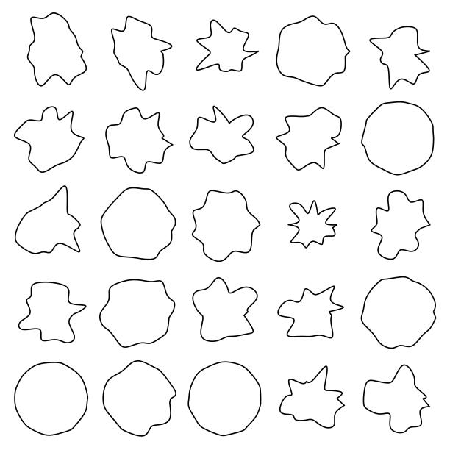

Definition
# Source: AI Source: Provided by: [Data Path: Persons Table -> ID Column: 1, Name_En Column: Motasem Essam] -> From: [ChatGPT] on [7/25/2026]
An Irregular Curved Shape is a two-dimensional geometric figure whose boundary is made entirely of curved lines and does not have a uniform or regular form.
Unlike regular curved shapes such as circles and ellipses, irregular curved shapes do not follow a fixed mathematical pattern and usually have:
- Unequal curvature.
- No constant radius.
- No equal dimensions.
- No perfect symmetry.
They are often used to represent natural objects and complex designs.

Characteristics
# Source: AI Source: Provided by: [Data Path: Persons Table -> ID Column: 1, Name_En Column: Motasem Essam] -> From: [ChatGPT] on [7/25/2026]
An irregular curved shape:
- Is a 2D figure.
- Has a boundary made of curves only.
- Has no straight edges.
- Usually has no vertices.
- Does not follow a simple geometric equation.
- May be:
  - Closed.
  - Open.
- Can be symmetrical or asymmetrical.
- Often requires approximation methods for measurement.

Illustration

Irregular Closed Curved Shape
# Source: AI Source: Provided by: [Data Path: Persons Table -> ID Column: 1, Name_En Column: Motasem Essam] -> From: [ChatGPT] on [7/25/2026]
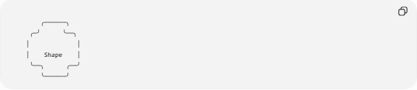
╭──────╮
╭─╯ ╰──╮
│ │
│ Shape │
╰──╮ ╭──╯
╰──────╯
The boundary is curved but not a perfect circle or ellipse.

Natural Irregular Curved Shape
# Source: AI Source: Provided by: [Data Path: Persons Table -> ID Column: 1, Name_En Column: Motasem Essam] -> From: [ChatGPT] on [7/25/2026]
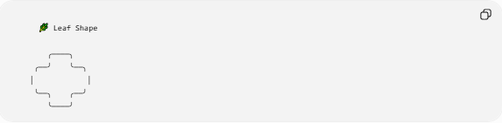
🌿 Leaf Shape

╭────╮
╭──╯ ╰──╮
│ │
╰──╮ ╭──╯
╰────╯

Mathematical Representation
# Source: AI Source: Provided by: [Data Path: Persons Table -> ID Column: 1, Name_En Column: Motasem Essam] -> From: [ChatGPT] on [7/25/2026]
Unlike circles:
$$x^{2}+y^{2}=r^{2}$$
irregular curved shapes usually require:
- Parametric curves:
$$x=f\left(t\right), y=g\left(t\right)$$
- Spline curves:
$$C\left(t\right)=\sum_{i}{N_{i}\left(t\right)P_{i}}$$
- Numerical approximation methods.

Types of Irregular Curved Shapes

1. Natural Irregular Curved Shapes
# Source: AI Source: Provided by: [Data Path: Persons Table -> ID Column: 1, Name_En Column: Motasem Essam] -> From: [ChatGPT] on [7/25/2026]
Found in nature.
Examples:
- Leaves.
- Clouds.
- Rocks.
- Islands.
- Tree branches.
- Water boundaries.

2. Freeform Curved Shapes
# Source: AI Source: Provided by: [Data Path: Persons Table -> ID Column: 1, Name_En Column: Motasem Essam] -> From: [ChatGPT] on [7/25/2026]
Designed by humans without fixed geometric rules.
Examples:
- Logos.
- Artistic drawings.
- Product designs.
- Decorative patterns.

3. Organic Curved Shapes
# Source: AI Source: Provided by: [Data Path: Persons Table -> ID Column: 1, Name_En Column: Motasem Essam] -> From: [ChatGPT] on [7/25/2026]
Shapes inspired by living organisms.
Examples:
- Human body outlines.
- Animal forms.
- Flower shapes.

4. Irregular Closed Curves
# Source: AI Source: Provided by: [Data Path: Persons Table -> ID Column: 1, Name_En Column: Motasem Essam] -> From: [ChatGPT] on [7/25/2026]
Curves that form a complete enclosed region.
Examples:
- Irregular lake boundary.
- Random blob shapes.
- Biological cell outlines.

5. Irregular Open Curves
# Source: AI Source: Provided by: [Data Path: Persons Table -> ID Column: 1, Name_En Column: Motasem Essam] -> From: [ChatGPT] on [7/25/2026]
Curves that do not close.
Examples:
- Hand-drawn curves.
- River paths.
- Freeform strokes.

Properties
# Source: AI Source: Provided by: [Data Path: Persons Table -> ID Column: 1, Name_En Column: Motasem Essam] -> From: [ChatGPT] on [7/25/2026]
1. Variable Curvature
The curve changes continuously:
$$κ_{1}≠κ_{2}$$
where:
$$κ$$
represents curvature.

2. No Fixed Radius
Unlike circles:
Circle:
$$r=\text{constant}$$
Irregular curve:
$$r≠\text{constant}$$

3. Complex Boundary
The boundary may contain many changes in direction.

4. Difficult Measurement
Measurements often require:
- Approximation.
- Numerical integration.
- Computer algorithms.

Area of Irregular Curved Shapes
# Source: AI Source: Provided by: [Data Path: Persons Table -> ID Column: 1, Name_En Column: Motasem Essam] -> From: [ChatGPT] on [7/25/2026]
The area can be calculated using:

1. Approximation Method
# Source: AI Source: Provided by: [Data Path: Persons Table -> ID Column: 1, Name_En Column: Motasem Essam] -> From: [ChatGPT] on [7/25/2026]
Using grids:
$$A≈\text{number of covered squares}$$

2. Numerical Integration
# Source: AI Source: Provided by: [Data Path: Persons Table -> ID Column: 1, Name_En Column: Motasem Essam] -> From: [ChatGPT] on [7/25/2026]
For coordinate-based curves:
$$A=\int_{a}^{b}{f\left(x\right)},dx$$

3. Computer Methods
# Source: AI Source: Provided by: [Data Path: Persons Table -> ID Column: 1, Name_En Column: Motasem Essam] -> From: [ChatGPT] on [7/25/2026]
Used in:
- CAD.
- GIS.
- Image processing.

Examples
# Source: AI Source: Provided by: [Data Path: Persons Table -> ID Column: 1, Name_En Column: Motasem Essam] -> From: [ChatGPT] on [7/25/2026]
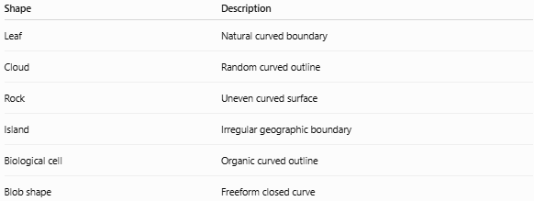
Shape | Description
Leaf | Natural curved boundary
Cloud | Random curved outline
Rock | Uneven curved surface
Island | Irregular geographic boundary
Biological cell | Organic curved outline
Blob shape | Freeform closed curve

Irregular Curved Shapes vs Regular Curved Shapes
# Source: AI Source: Provided by: [Data Path: Persons Table -> ID Column: 1, Name_En Column: Motasem Essam] -> From: [ChatGPT] on [7/25/2026]
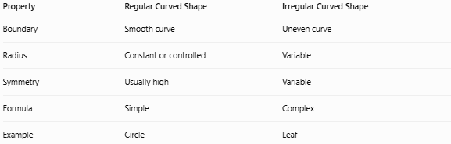
Property | Regular Curved Shape | Irregular Curved Shape
Boundary | Smooth curve | Uneven curve
Radius | Constant or controlled | Variable
Symmetry | Usually high | Variable
Formula | Simple | Complex
Example | Circle | Leaf

Irregular Curved Shapes vs Irregular Polygonal Shapes
# Source: AI Source: Provided by: [Data Path: Persons Table -> ID Column: 1, Name_En Column: Motasem Essam] -> From: [ChatGPT] on [7/25/2026]
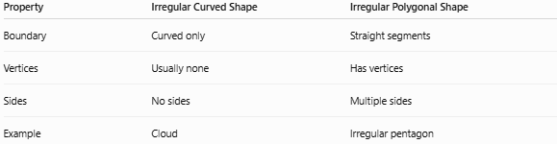
Property | Irregular Curved Shape | Irregular Polygonal Shape
Boundary | Curved only | Straight segments
Vertices | Usually none | Has vertices
Sides | No sides | Multiple sides
Example | Cloud | Irregular pentagon

Real-World Examples
# Source: AI Source: Provided by: [Data Path: Persons Table -> ID Column: 1, Name_En Column: Motasem Essam] -> From: [ChatGPT] on [7/25/2026]
Irregular curved shapes are everywhere:
- Coastlines.
- Human organs.
- Plants.
- Clouds.
- Rocks.
- Lakes.
- Animal bodies.
- Product designs.

Applications
# Source: AI Source: Provided by: [Data Path: Persons Table -> ID Column: 1, Name_En Column: Motasem Essam] -> From: [ChatGPT] on [7/25/2026]
Irregular curved shapes are important in:
- Plane Geometry.
- Differential Geometry.
- Biology.
- Geography.
- GIS (Geographic Information Systems).
- Architecture.
- Engineering.
- CAD (Computer-Aided Design).
- Computer Graphics.
- Medical Imaging.

Advantages
# Source: AI Source: Provided by: [Data Path: Persons Table -> ID Column: 1, Name_En Column: Motasem Essam] -> From: [ChatGPT] on [7/25/2026]
Studying irregular curved shapes helps to:
- Model natural objects accurately.
- Design complex products.
- Analyze biological structures.
- Represent geographic boundaries.
- Create realistic computer graphics.

Limitations
# Source: AI Source: Provided by: [Data Path: Persons Table -> ID Column: 1, Name_En Column: Motasem Essam] -> From: [ChatGPT] on [7/25/2026]
Irregular curved shapes:
- Lack simple formulas.
- Are difficult to measure exactly.
- Often require computational methods.
- Cannot usually be described by basic geometric equations.

Key Points
# Source: AI Source: Provided by: [Data Path: Persons Table -> ID Column: 1, Name_En Column: Motasem Essam] -> From: [ChatGPT] on [7/25/2026]
- An Irregular Curved Shape has a curved boundary with no regular pattern.
- It has:
  - No straight edges.
  - Usually no vertices.
  - Variable curvature.
- Examples:
  - Leaves.
  - Clouds.
  - Rocks.
  - Islands.
  - Organic shapes.

Conclusion
# Source: AI Source: Provided by: [Data Path: Persons Table -> ID Column: 1, Name_En Column: Motasem Essam] -> From: [ChatGPT] on [7/25/2026]
An Irregular Curved Shape is a two-dimensional figure formed entirely by curves that do not follow a regular mathematical pattern. Unlike circles and ellipses, these shapes have variable curvature and complex boundaries. They are essential for representing real-world objects in geometry, biology, geography, engineering, CAD, GIS, computer graphics, and medical imaging, where natural and designed forms rarely follow perfect geometric rules.

